Table of Contents

SECTION 1: THE SMALL SOCIALLY-DISADVANTAGED PRODUCER GRANT
PROGRAM 1

1.1 Introduction 3

1.2 Authorization 3

1.3 Available Funding for FY 2010 3

1.4 SSDPG Program Contacts 3

1.5 SSDPG Resources on the Web 3

SECTION 2: GENERAL CONSIDERATIONS FOR AN SSDPG GRANT 4

2.1 Eligible Entities 4

2.2 Eligible Grant Purposes 4

2.3 Grant Period Eligibility 4

2.4 Other Eligibility 4

2.5 Ineligible Grant Purposes 4

2.6 Security Requirements 5

SECTION 3: APPLICATION SUBMISSION PROCESS 5

3.1 Filing Applications 5

3.2 DUNS Number Requirement 5

3.3 Paper Applications 6

3.4 Electronic Applications 6

3.5 Deadlines for Applications 6

SECTION 4: REQUIREMENTS FOR A COMPLETED GRANT 7

4.1 Preparing the Application 7

4.2 Required Forms 7

4.3 Proposal 7
4.3.1 Table of Contents 7
4.3.2 Executive Summary 7
4.3.3 Eligibility Discussion 7
4.3.4 Work Plan and Budget 8
4.3.5 Proposal Evaluation Criteria 8

SECTION 5: APPLICATION REVIEW PROCESS 8

5.1 Eligibility Screening 8

5.2 Evaluating the Application 8

5.3 Scoring Criteria 8

5.4 Application Selection 8

5.5 Possible RBS Actions on the Application 9

5.6 Appeals Process 9

Appendix A – Rules and Regulations 10

Appendix B – Application Checklist 11

Appendix C –Application Outline 13
Section 1: The SMALL SOCIALLY-DISADVANTAGED PRODUCER Program

  - Introduction

The primary objective of this grant program is to provide technical assistance to small, socially-disadvantaged agricultural producers through eligible Cooperatives and Association of Cooperatives.

In this guide, you will find information to help you:

- Assess your eligibility for the SSDPG program
- Understand how and when to apply
- Create a successful application

1.2 Authorization

Agriculture, Rural Development, Food and Drug and Related Agencies Appropriations Act 2010 authorizes this program under the Rural Cooperative Development Grant program.

The SSDPG (formerly the Small Minority Producer Grant program) program is administered by the Rural Business-Cooperative Service (RBS) with assistance from Rural Development (RD) field office staff. RBS has published a Notice of Funding Availability (NOFA) in the Federal Register requesting applications for the current funding cycle. The NOFA contains the application requirements as well as other program information. You should use the NOFA in conjunction with this Guide when assembling your application.

1.3 Available Funding for FY 2010

For fiscal year 2010, approximately $3.463 million is available for the grant program.

1.4 SSDPG Program Contacts

We encourage you to contact the Rural Development State Office for your state early in the application process with any questions or ideas concerning your application. The staff will provide advice on draft applications before the application deadline or answer your questions about the application process and program requirements. Please only contact the National Office staff if you are unable to reach the representative from your state.

National Office
(202) 720-8460
cpgrants@wdc.usda.gov

1.5 SSDPG Resources on the Web

Visit our website at http://www.rurdev.usda.gov/rbs/coops/ssdpg/ssdpg.htm.

Section 2: General Considerations for an SSDPG

2.1 Eligible Entities

An entity is eligible to receive an SSDPG if it is an Association of Cooperatives or a Cooperative whose primary focus is to provide assistance to small, socially-disadvantaged producers and whose governing board and/or membership is comprised of at least 75 percent small, socially disadvantaged producers. Applicants will be required to verify their legal structure as a Cooperative or as an Association of Cooperative in the state in which they are incorporated at the time of application. Public bodies and Individuals are not eligible to receive grants.

2.2 Eligible Grant Purposes

Grant funds must be used for Technical Assistance. Technical assistance is defined as: An advisory service performed for the benefit of a small, socially-disadvantaged producer such as market research; product and/or service improvement/ legal advice and assistance; feasibility study, business plan, and marketing plan development; and training.

2.3 Grant Period Eligibility

Applications should have a timeframe of no more than 365 days with the time period beginning no earlier than October 1, 2010 and ending no later than December 31, 2011. Projects must be completed within the 12-month time frame.

2.4 Other Eligibility

- The proposed project must take place in a rural area as defined in the NOFA.
- Applications without sufficient information to determine eligibility and scoring will not be considered for funding.
- Applications that are non-responsive to the notice will be ineligible for funding.

2.5 Ineligible Grant Purposes

Grant funds shall not be used to pay for any of the following activities.

- Duplicate current services or replace or substitute support previously provided. If the current service is inadequate, however, grant funds may be used to expand the level of effort or services beyond that which is currently being provided;
- Pay costs of preparing the application package for funding under this program;
- Pay costs of the project incurred prior to the date of grant approval;
- Fund political or lobbying activities;
- Pay for assistance to any private business enterprise that does not have at least 51 percent ownership by those who are either citizens of the United States or reside in the United States after being legally admitted for permanent residence;
- Pay any judgment or debt owed to the United States;
- Plan, repair, rehabilitate, acquire, or construct a building or facility, including a processing facility;
- Purchase, rent, or install fixed equipment, including processing equipment;
- Purchase vehicles, including boats;
- Pay for operating costs of cooperatives or association of cooperatives;
- Fund research and development;
- Fund any activities prohibited by 7 CFR part 3015 or 3019;
- Pay expenses for applicant employee training;
- Pay expenses not directly related to the funded project;
- Fund any direct expenses related for the production of any commodity or product to which value will be added, including seed, rootstock, labor for harvesting the crop, and delivery of the commodity to a processing facility; or
- Purchase land.
- Fund architectural or engineering design work for a specific physical facility.

2.6 Security Requirements

A grant agreement will be executed between the recipient and RBS.

Section 3: Application Submission Process

3.1 Filing Applications

You may file an application in either paper or electronic format. Send paper applications by U.S. Postal Service or courier delivery services to the address listed in Section 3.3 of this Guide. File an application electronically through http://www.grants.gov, the official Federal Government website. RBS will not accept applications by fax or e-mail.

3.2 DUNS Number Requirement

Whether you file a paper or an electronic application, you will need a Dun and Bradstreet Data Universal Numbering System (DUNS) number. You must provide your DUNS number on the SF-424, “Application for Federal Assistance.”

To verify that your organization has a DUNS number or to receive one at no cost, call the dedicated toll-free request line at (866) 705-5711 or access the website at: http://www.dnb.com/us/. You will need the following pieces of information when requesting a DUNS number.

- Legal name
- Headquarters name and address of the organization
- Doing business as (dba) or other name by which the organization is commonly recognized
- Physical address
- Mailing address (if separate from headquarters and/or physical address)
- Telephone number
- Contact name and title
- Number of employees at the physical location

3.3 Paper Applications

Paper applications must be received by the deadline date and time. Send an original paper application (no stamped, photocopied, or initialed signatures) to the appropriate State Office as defined in the NOFA. The application and any materials sent with it become Federal records by law and cannot be returned to you.

3.4 Electronic Applications

File an electronic application at the website: http://www.grants.gov. Note that you will need to follow the instructions on the website to submit an application. Your submission will include the required forms (outlined below) and an attachment which should include all remaining elements of your application.

You must be registered with Grants.gov before you can submit an application. If you have not used Grants.gov before, you will need to register with the Central Contractor Registry (CCR) and the Credential Provider. You will need a DUNS number to access or register at any of the services. The registration process may take several business days to complete. Follow the instructions at Grants.gov for registering and submitting an electronic application. RBS may request original signatures on electronically submitted documents later.

The CCR registers your organization, housing your organizational information and allowing Grants.gov to use it to verify your identity. You may register for the CCR by calling the CCR Assistance Center at (888) 227-2423 or you may register online at: http://www.ccr.gov.

The Credential Provider gives you or your representative a username and password, as part of the Federal Government’s e-Authentication to ensure a secure transaction. You will need the username and password when you register with Grants.gov or use Grants.gov to submit your application. You must register with the Credential Provider through Grants.gov at the following website: https://apply.grants.gov/OrcRegister.

3.5 Deadline for Grant Applications

The deadline to submit application is listed under section IV.C. of the NOFA.

All applications must be received by the filing deadline to be considered for funding.

An application will be considered on time if it is postmarked and mailed, shipped, or sent overnight no later than the deadline date. If the application is filed electronically, an electronic date and time stamp on or before the deadline will be considered on time. Paper applications must arrive at the State Office address listed in the NOFA.

Section 4: Requirements for a Completed Grant

4.1 Preparing the Application

A complete application includes the following elements.

- Standard application forms
- Proposal

To be considered for an SSDPG, you must meet the eligibility requirements and you must submit a complete application by the deadline date and time. You should consult the cost principles (OMB Circular A-122 and the Federal Acquisition Regulation, Section 31.2) and general administrative requirements for grants (7 CFR parts 3015 and 3019) in order to prepare the budget and complete other parts of the application.

4.2 Required Forms

Applicants must complete and submit the following forms to apply for a SSDPG.

- SF-424, “Application for Federal Assistance”
- SF-424A, “Budget Information-Non-Constructions Programs”
- SF-424B, “Assurances – Non-Construction Programs”

4.3 Proposal

4.3.1 Table of Contents

The Table of Contents should include page numbers for each main element of the application, including the Proposal Evaluation Criteria.

4.3.2 Executive Summary

A summary of the proposal, not to exceed one page, must briefly describe the project, tasks to be completed and other relevant information that provides a general overview of the project.

4.3.3 Eligibility Discussion

The eligibility discussion must provide a detailed discussion, not to exceed 4 pages, describing how the applicant meets the eligibility requirements. Applicant must also verify their incorporation as a cooperative or an association of cooperatives in the State they have applied by providing the State’s Certificate of Good Standing, their Articles of Incorporation and By-Laws.

4.3.4 Work Plan and Budget

The applicant must describe in detail (not to exceed 4 pages) the purpose of the grant, what type of assistance will be provided and the total amount of funds needed to assist each project. The budget must also present a breakdown of the estimated costs associated with technical assistance activities as well as allocating these costs to each of the tasks to be undertaken for each project. Projects proposing to pay for the operating costs of cooperatives will not be considered.

4.3.5 Evaluation Criteria

Each of the proposal evaluation criteria referenced in the NOFA must be addressed, specifically and individually, in narrative form not to exceed 2 pages for each criterion. The criteria are listed below.

- Technical Assistance
- Experience
- Commitment
- Local Support

Section 5: Application Review Process

5.1 Eligibility Screening

Your application will be initially screened to determine if it is complete and eligible. If your application is determined to be complete and eligible, it will be further evaluated. If you application is determined to be incomplete, ineligible, or both, you will be notified of the reasons.

5.2 Evaluating the Application

Each complete and eligible application will be evaluated by a federal employee with experience in business development.

5.3. Scoring Criteria

Applications that are complete and eligible will be ranked competitively based on the criteria listed in Section 4.3.4 of this Guide. .

5.4 Application Selection

RBS will rank all complete and eligible applications by their final score. Applications will be selected for funding in rank order, subject to the availability of SSDPG funds.

5.5 Possible RBS Actions on an Application

In making its decision about your application, RBS may determine that your application is:

- Eligible and selected for funding
- Eligible, but offered fewer funds than requested
- Eligible, but not selected for funding
- Ineligible for funding

5.6 Appeals Process

In accordance with 7 CFR part 11, you generally have the right to appeal RBS decisions that are adverse to you. RBS will notify you of your appeal rights when it notifies you of the decision for your application. If RBS has determined its decision is not appealable, you may request that the National Appeals Division (NAD) determine the appealability of a specific decision. The request must be in writing and filed at the appropriate Regional Office, which can be found at http://www.nad.usda.gov/offices.htm or by calling (703) 305-1166.
Appendix A – Rules and Regulations

These rules and regulations have been mentioned throughout the text of this Guide, but are listed in one place for easy reference. The Code of Federal Regulations (CFR) is located at http://www.gpoaccess.gov/cfr/index.html. The OMB Circulars are located at http://www.whitehouse.gov/omb/grants/grants_circulars.html. The Federal Acquisition Regulation is located at http://www.arnet.gov/far/.

- CFR, Title 7, Part 11, subpart A, “National Appeals Division Rules of Procedures”
- CFR, Title 7, Part 3015, “Uniform Federal Assistance Regulations”
- CFR, Title 7, Part 3019, “Uniform Administrative Requirements for Grants and Agreements with Institutions of Higher Education, Hospitals, and Other Non-Profit Organizations”
- OMB Circular A-122, “Cost Principles for Non-Profit Organizations”
Appendix B – Application Checklist

Form of submission
- Submission includes all pages of the application

Content of submission
- 1. Form SF-424
- Legal name of applicant (Item 5)
- Applicant’s DUNS number (Item 5)
- Applicant’s complete mailing address (Item 5)
- Name of contact person (Item 5)
- Telephone number of contact person (Item 5)
- Employer Identification Number (Item 6)
- Proposed start date of project (Item 13)
- Proposed end date of project (Item 13)
- Federal funds requested (Item 15a)
- Answer to question, “Is applicant delinquent on any federal debt?” (Item 17)
- Name of authorized representative (Item 18a)
- Telephone number of authorized representative (Item 18c)
- Signature of authorized representative (Item 18d)
- Date form was signed (Item 18e)

- 2. Form SF-424A
- Section A
- Section B
- Section C (note that matching funds are not required for SSDPG)
- Section D

- 3. Form SF-424B
- Signature of authorized representative
- Title of authorized representative
- Name of authorized representative
- Date signed by authorized representative

- 4. Proposal

- i. Table of Contents

- Page number Executive Summary
- Page number for Eligibility Discussion
- Page number for Budget and Work Plan
- Page number of Evaluation Criteria

- ii. Executive Summary (limit = 1 page)

- Describe the project
- Describe the tasks to be completed
- Describe other relevant information that provides general overview of the project.

- iii. Eligibility Discussion (limit = 4 pages)

- a. Applicant.
- Describe how you meet the definition of an eligible Cooperative or Association of Cooperative, as defined in the Notice
- Verify that you are incorporated as a Cooperative or an Association of Cooperative in the State where you applied.
- Provide a copy of State’s Certificate of Good Standing
- Provide a copy of Article’s of Incorporation
- Provide a copy of Bylaws

- b. Use of Funds. Describe how the proposed project activities meet the definition of technical assistance.

- c. Project Area. Describe where the proposed projects are located and that the areas meet the definition of rural area.

- d. Grant Period. Describe the proposed grant period and how the project will be completed within the time frame. It must not be more than 365 days. Beginning no earlier than October 1, 2010, and ending no later than December 31, 2011.

- iv. Work Plan/Budget (limit = 4 pages)
- Describe the purpose of the grant
- Describe the type of assistance and the total amount needed for each project
- Budget must present a breakdown of estimated costs associated with activities/tasks for each project

- 5. Evaluation Criteria (limit = 2 pages for each criterion)
- i. Technical Assistance
- ii. Experience
- iii. Commitment
- iv. Local Support – you may submit up to 10 letters of support

Appendix C – Application Outline

This appendix provides a suggested, not required, format for a 2010 SSDPG application. Each required element is listed with the relevant text from the NOFA. Many of the elements also include sample language and/or tables.

Please note: You MUST read the NOFA. Simply following the sample format does not guarantee that your application will be determined to be eligible and complete, or that it will be funded. If you have questions during the application process, please contact your state representative.
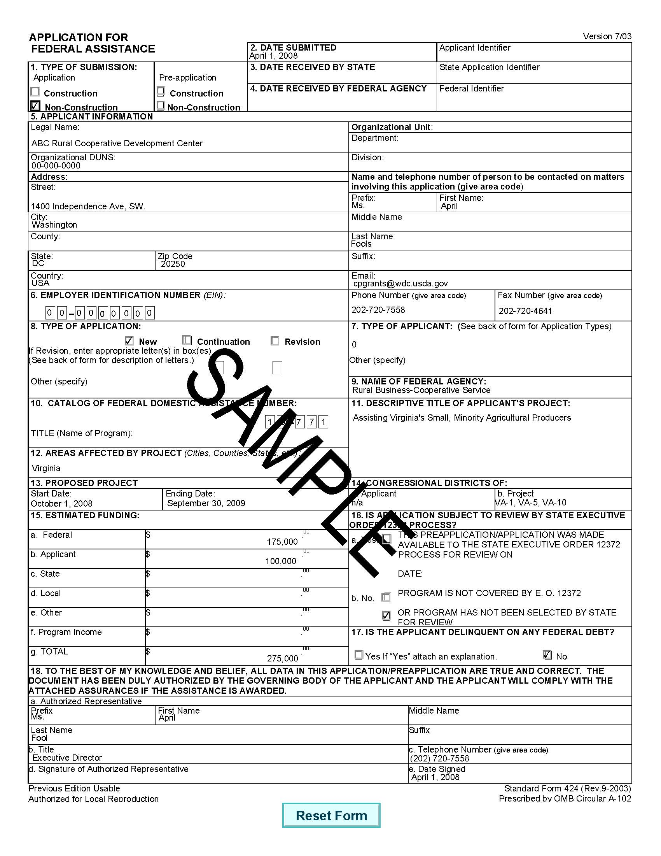

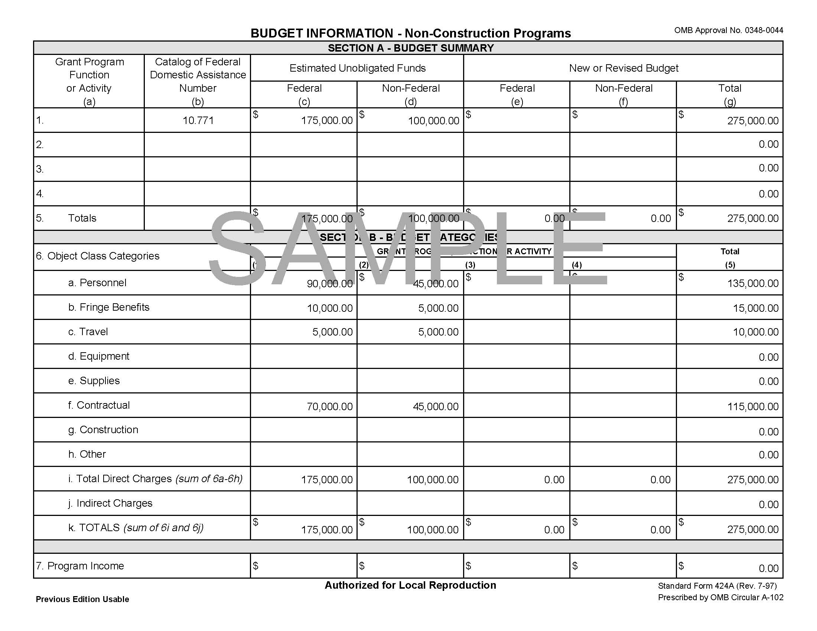

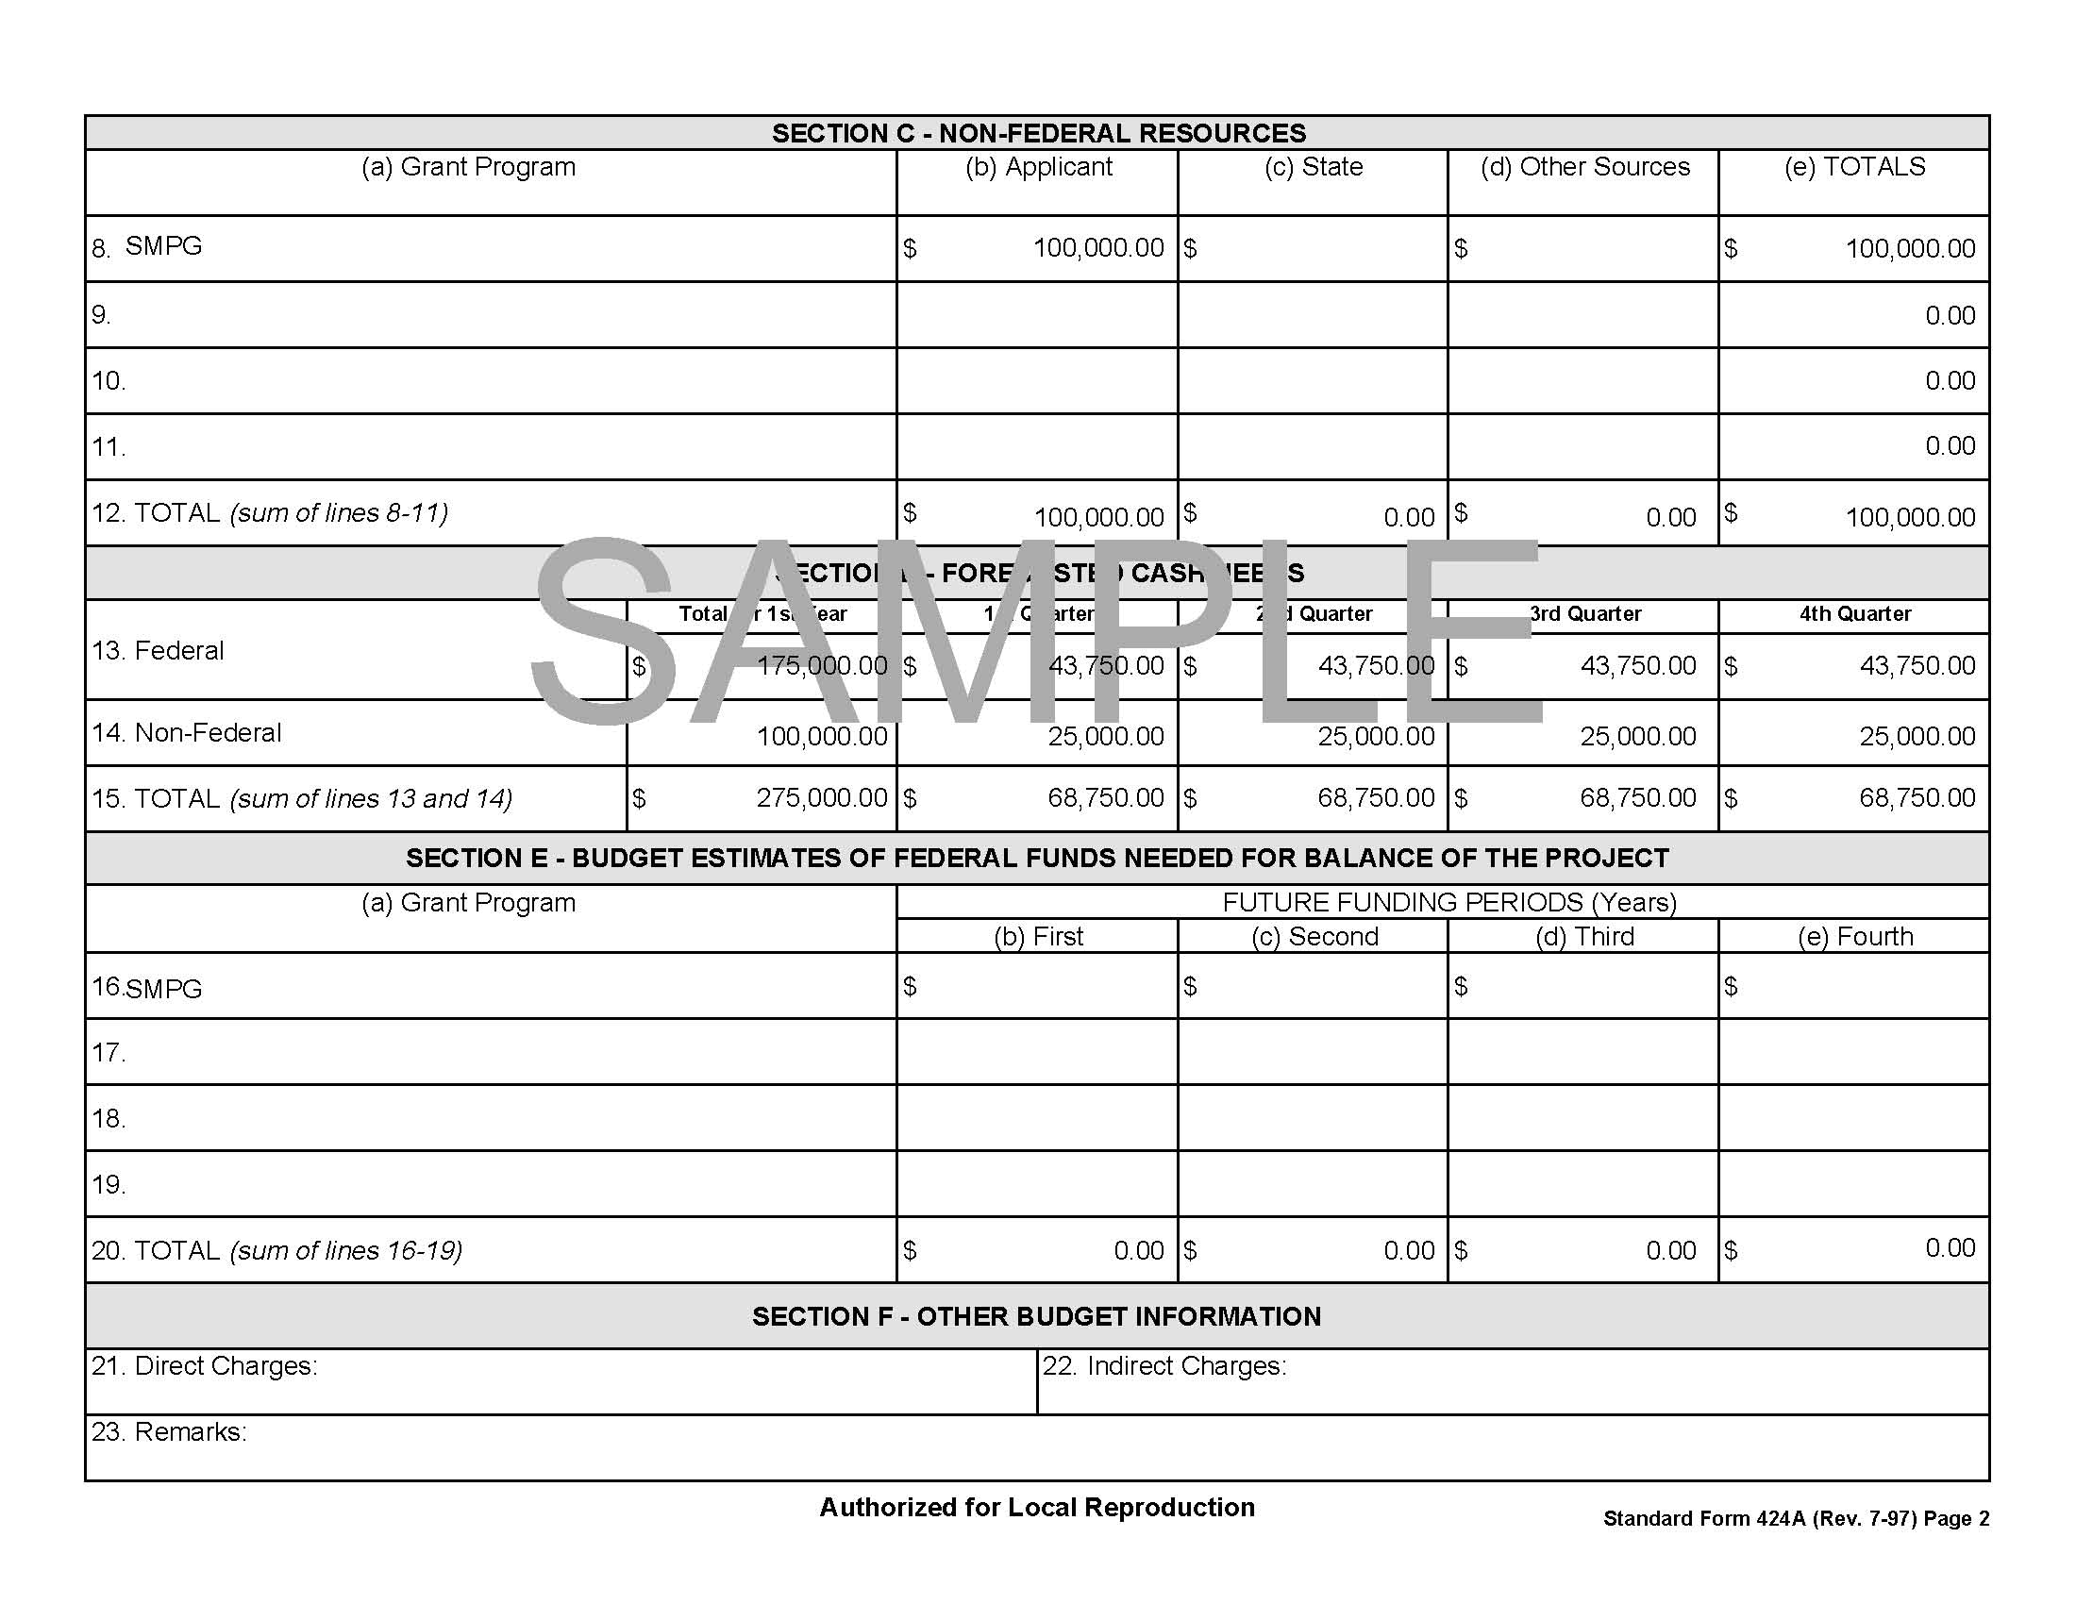

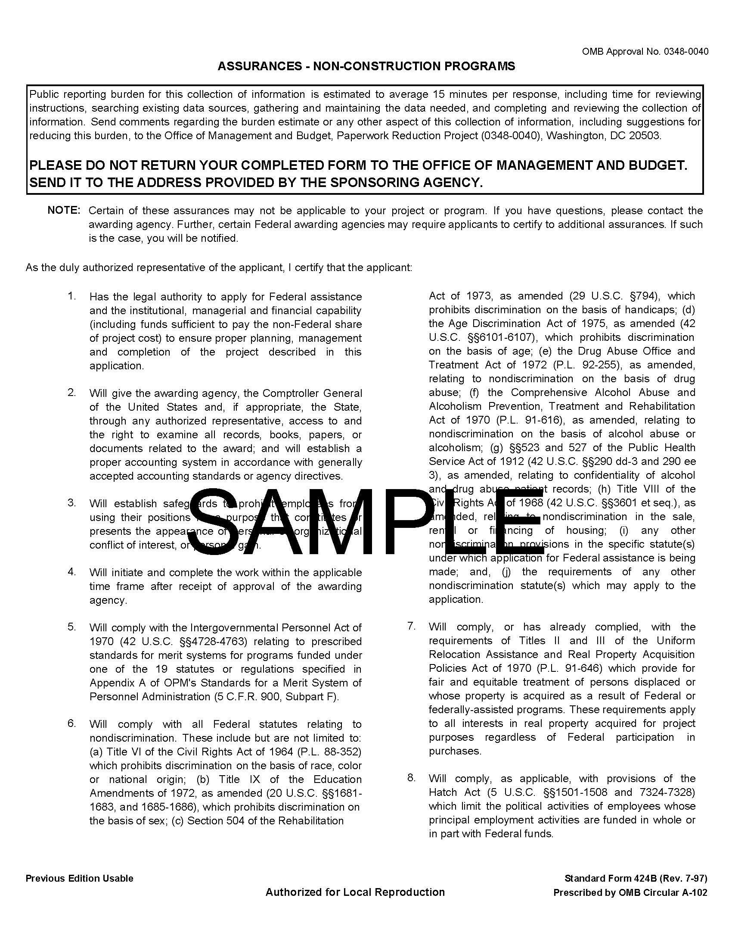

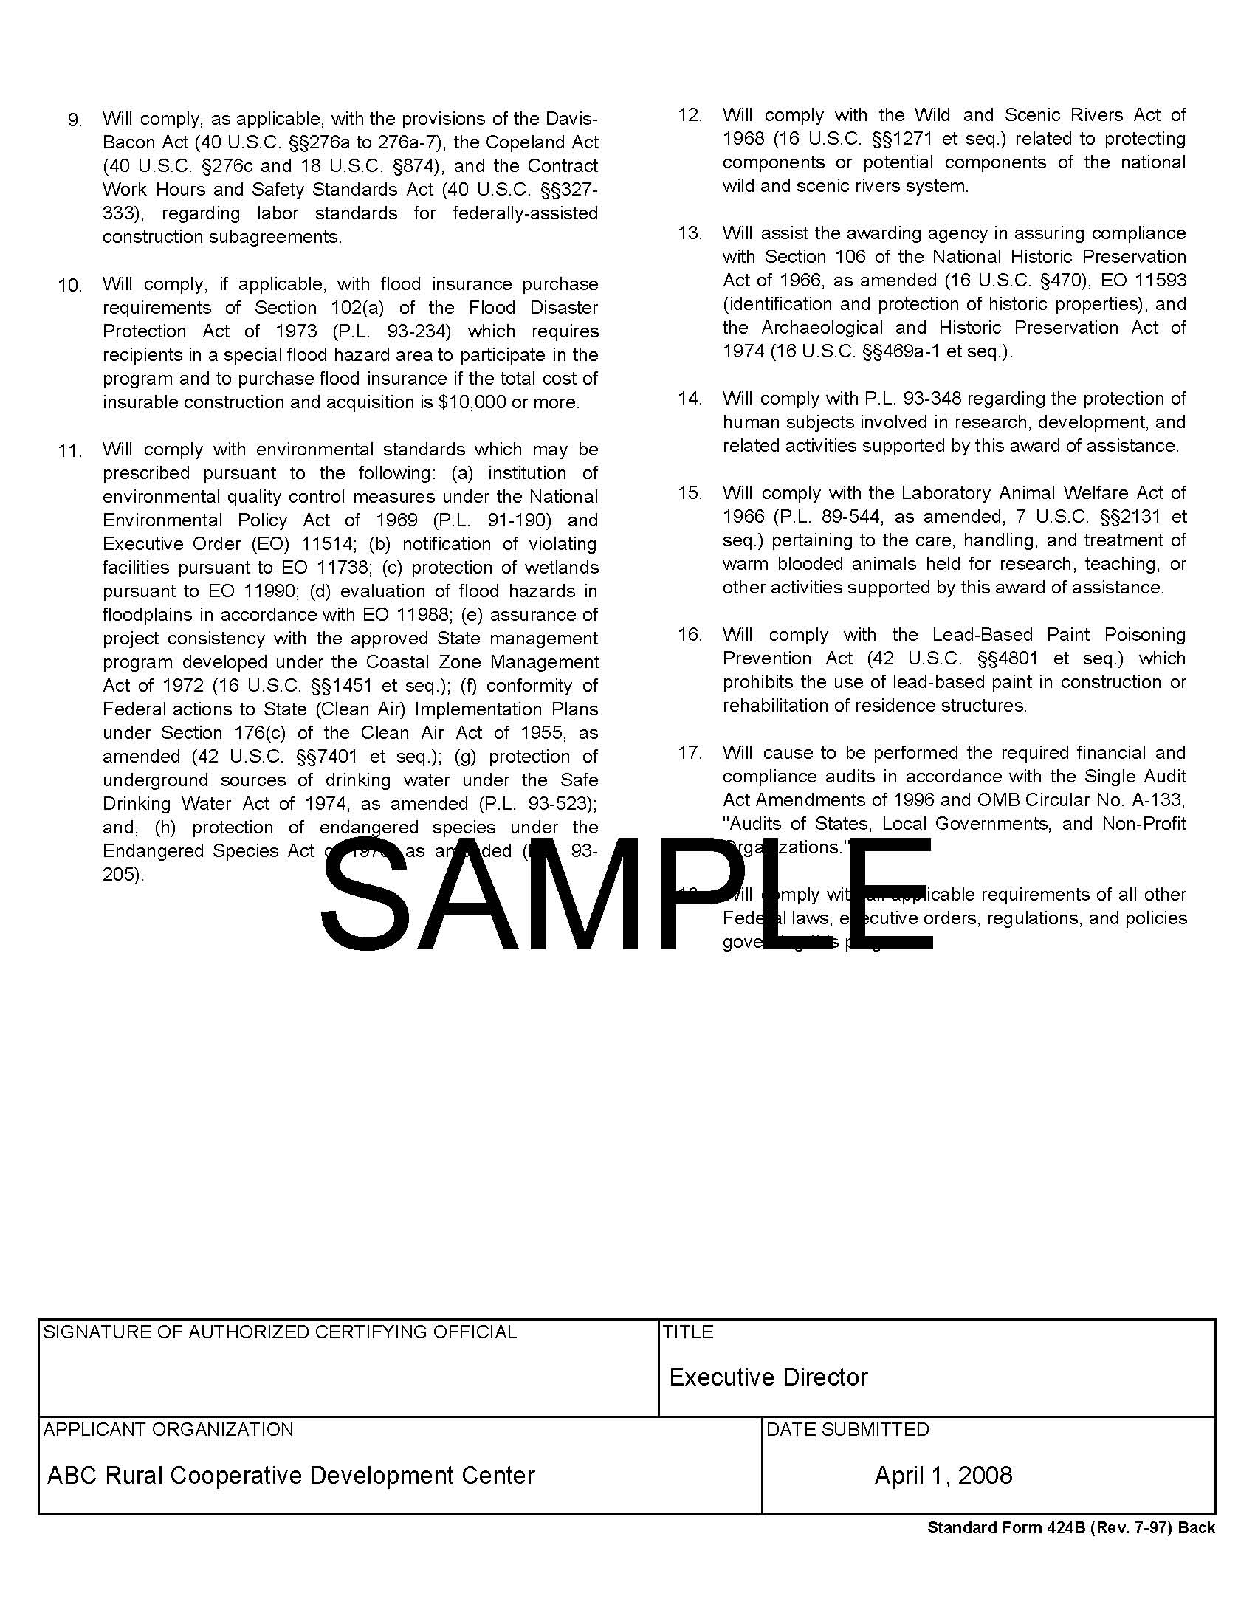

Table of Contents

For ease of locating information, each proposal must contain a detailed Table of Contents (TOC) immediately following the Title Page. The TOC should include page numbers for each component of the proposal. Pagination should begin immediately following the TOC. The TOC should include page numbers for the Eligibility Discussion, Budget and Work Plan and Evaluation Criteria. It is recommended that the applicant start their application with the required forms and number those forms beginning with the Roman numeral “i.” The Title Page and Table of Contents should also be numbered with small Roman numerals. The Executive Summary should be page number 1. Example language is included below.

Table of Contents

Element Page

SF-424 i

SF-424A ii

SF-424B iii

Table of Contents iv

Executive Summary 1

Eligibility Discussion 2

Budget/Work Plan 3

Evaluation Criteria 4
Eligibility Discussion

Describe in detail how the applicant meets the eligibility requirements. This discussion is
limited to four (4) pages. Pages in excess of the four-page limit will not be considered.

Applicant: Applicants must describe how they meet the definition of an eligible “cooperative” or “association of cooperative” as defined in the Definitions section of the Notice. Applicants must also provide a copy of their State’s Certificate of Good Standing, Articles of Incorporation, and By-Laws from the State they have applied in to verify their incorporation as a cooperative or an association of cooperatives.
Use of Funds: Applicants must provide a detailed discussion on how the proposed project activities meet the definition of technical assistance as defined in the Notice.
Project Area: Applicants must provide specific information on where the projects are planned to be located and that the areas meet the definition of “rural area” as defined in the Notice.
Grant Period: Applicants must provide a time frame for the proposed project and discuss how the project will be completed within that 12-month time frame.
Budget/Work Plan

The Applicant must describe in detail (not to exceed 4 pages) the purpose of the grant, what type of assistance will be provided and the total amount of funds needed to assist each project. The budget must also present a breakdown of the estimated costs associated with the technical assistance activities as well as allocating these costs to each of the tasks to be undertaken for each project. Applicants should also discuss each proposed task in narrative form as part of the work plan and explain the costs for the budget. Example tables are included below.

Task | Personnel | Time Period | Grant Funds | Matching Funds | Total Cost

 | Budget Category 1 |  | Budget Category 2 |  | Budget Category 3 |  | Total
 | Grant | Match | Grant | Match | Grant | Match | Grant | Match
Task 1
Task 2
Task 3

Proposal Evaluation Criteria

Each of the evaluation criteria referenced in Section V.A. must be specifically and individually addressed in narrative form.

1. Technical Assistance. The application will be evaluated to determine the applicant’s ability to assess the needs of small socially-disadvantaged producers, plan and conduct appropriate and effective assistance, and identify the expected outcomes of that assistance.

2. Experience. Points will be awarded based upon length of experience of identified staff or consultants in providing technical assistance.

3. Commitment. The Agency will evaluate the applicant’s commitment to providing technical assistance to small, socially-disadvantaged producers in rural areas. Points will be awarded based upon the number of agricultural, small, socially-disadvantaged producers being assisted.

4. Local Support. Points will be awarded based on the strength of support from potential beneficiaries of the technical assistance activities of the cooperative and from other developmental organizations. The application may also contain 10 letters of support to provide evidence of local support.

