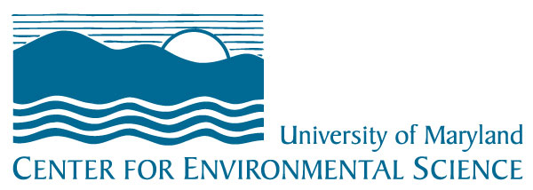
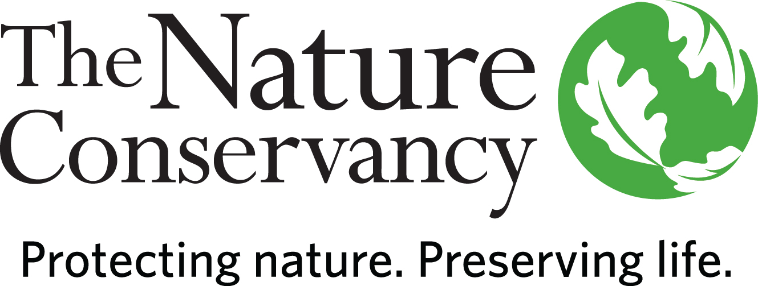
The Nature Conservancy

University of Maryland Center for Environmental Science
POSITION PROFILE
TNC - UMCES Sustainable Agriculture Fellow (Applied Scientist III)
Maryland/DC Chapter
The Nature Conservancy is the leading conservation organization working to make a positive impact around the world in 79 countries and territories, all 50 United States, and your backyard. Founded in 1951, our mission is to conserve the lands and waters on which all life depends. One of our core values is our commitment to a globally diverse and culturally competent workforce. Visit www.nature.org/aboutus to learn more.
The University of Maryland Center for Environmental Science (UMCES) leads the way toward better management of Maryland’s natural resources and the protection and restoration of the Chesapeake Bay. As Maryland’s graduate university for the environment, we train students to be environmental leaders of the future. We employ an interdisciplinary, research-based curriculum to provide M.S. and Ph.D. students with the tools to develop impactful future careers. We fortify these strengths through diverse, collaborative, interdisciplinary teams to address and solve complex environmental problems. To learn more about UMCES, visit www.umces.edu.
This position is a novel collaboration between The Nature Conservancy (TNC) and the University of Maryland Center for Environmental Sciences (UMCES) and offers an exciting opportunity for a candidate who is interested in bridging academia and conservation. The TNC/UMCES Sustainable Agriculture Fellow will be an employee of TNC with a joint position at the UMCES. They provide technical and scientific support and leadership to implement and apply science to improve water quality and habitat in the face of a changing climate while sustaining agricultural economies and communities. The TNC/UMCES Sustainable Agriculture Fellow will be co-located with the University of Maryland Center for Environmental Science and The Nature Conservancy’s Maryland/DC Chapter to effectively link science to advancing TNC’s conservation goals and UMCES’ strategic goal of maintaining sustainable landscapes and seascapes. They will be a core member of TNC’s Sustainable Agriculture Team which works across Maryland and the Chesapeake Bay watershed. The Sustainable Agriculture Fellow will work closely with a variety of TNC and UMCES staff and external partners including scientists, federal, state, local and private land and resource managers and policy experts. The Sustainable Agriculture Fellow will collaborate with UMCES faculty and graduate students who are conducting research on sustainable agriculture and coordinate work among other University multi-disciplinary scientists. This position is scheduled to begin on July 1, 2020 and is a 3-year position with opportunities to develop into a permanent position.
Providing expertise, science leadership, and practical experience to improve water quality and habitat and accelerate efforts to build resiliency and mitigation strategies to climate change in agricultural landscapes, the Fellow will identify gaps in scientific knowledge, develop and implement collaborative research projects with UMCES and public and private partners, use their technical expertise to evaluate existing scientific studies and data to help guide conservation investments, and communicate scientific information with a variety of stakeholders.
Responsibilities and scope include design and implement experiments to advance conservation goals of TNC’s and UMCES’s Sustainable Agriculture Programs; build collaborative relationships with outside parties to accomplish program goals; evaluate and apply existing science to guide novel conservation approaches and policy reform; identify and build multi-disciplinary teams to address priority science needs including academic, governmental and other NGO and private business partners; oversee and coordinate science projects including proposal development, fieldwork and logistical support for research, monitoring, and communication of progress and results; and manage grant deliverables and budgets, as well as oversee contracts.
Minimum Qualifications
• Master's Degree in science related field and 4 years of experience or equivalent combination of education and experience.
• Experience manipulating, analyzing and interpreting statistical or environmental data.
• Record of peer reviewed publications in scientific journals.
• Experience fundraising and/or writing grants and research proposals.
• Experience leading or participating on cross functional teams.
• Experience managing complex projects including the financial aspect and coordinating the work of peers and partners.
• Experience working and communicating with a wide range of people.
With the support of more than one million members, the Conservancy addresses the most pressing threats to people and nature, working in wild places and in human settled areas including cities. Since its founding in 1951, The Nature Conservancy has protected more than 119 million acres of land and 5,000 miles of rivers worldwide. Through important and strategic partnerships, we are expanding the impact of our work, finding creative ways to pursue our vision of a world where people and nature thrive together, and building long-term relationships with communities and community organizations, government agencies, and commercial businesses. We create partnerships to apply nature-based solutions to both climate change and the meeting of human needs while conserving natural resources at a new scale.
From a network of laboratories located across the state, the University of Maryland Center for Environmental Science (UMCES)’s scientists provide sound advice to help state and national leaders manage the environment and prepare future scientists to meet the global challenges of the 21st century.
If you are interested in working to save the planet, want to work in a collaborative environment, and like a great benefits package, please submit your cover letter and resume for position number 48616 by 11:59 p.m. Eastern Time by April 5th, 2020. Please see the full position description and apply at www.nature.org/careers.
The Nature Conservancy is an Equal Opportunity Employer. Our commitment to diversity includes the recognition that our conservation mission is best advanced by the leadership and contributions of people of all genders with diverse backgrounds, beliefs and cultures. Recruiting and mentoring staff to create an inclusive organization that reflects our global character is a priority and we encourage applicants from all cultures, races, colors, religions, sexes, national or regional origins, ages, disability status, sexual orientations, gender identities, military or veteran status or other status protected by law.

