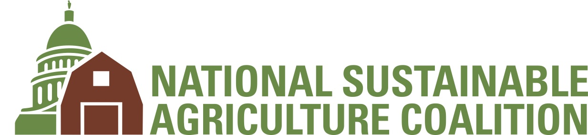
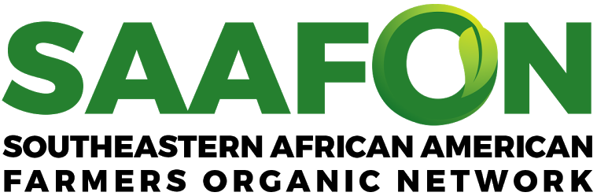
Cynthia Hayes Memorial Scholarship

Application Guidelines and Instructions
The Southeastern African American Farmers’ Organic Network (SAAFON), the National Sustainable Agriculture Coalition (NSAC), and Minorities in Agriculture Natural Resources and Related Sciences (MANRRS) have partnered together to create a scholarship in memory of Cynthia Hayes, co-founder and former director of SAAFON. Cynthia was a founder of the first network for African American organic farmers in the U.S. and dedicated her life to serving these communities. Spending time on her grandmothers farm in Kentucky as a young person, she learned about her family's history of over 80 years of tobacco farming. This laid the foundation for the work she would spend her life doing. Cynthia would go on to work in non-profits in the Bay Area, using her talents to support grant writing efforts and working in group homes before relocating with her husband to Jamaica where she began working directly with farmers. In 2000 Cynthia moved to Savannah, GA where her work centered on land, environmental justice and the plight of African American farmers. In addition to SAAFON, Cynthia was a founding member of several other non-profit organizations and programs that worked to build power among Black growers. Her impact and leadership was honored with several prestigious awards including the 2013 James Beard Award and the 2013 Southern Foodways Alliance John Egerton Award. Cynthia was an inspirational force in the development of NSAC’s equity platform and initiatives that followed. Her legacy lives on in the work that continues, and we hope to honor her vision with this scholarship empowering younger generations to continue this work.

Eligible students may apply for this scholarship (see eligibility requirements below). The students awarded the scholarship will each receive a $3000 award, presented at the MANRRS national conference, and the opportunity to connect with sustainable food and farm advocates and practitioners. The scholarship will be awarded during the Spring 2021 semester.

Eligibility:
- This scholarship is open to students who self-identify as Black and/or Indigenous
- Applications should be focused on sustainable agriculture and how it affects Black farmer communities, and food justice in the context of the United States
- Students should have an interest in grassroots organizing, movement building, or agricultural policy and a commitment to promoting racial equity in our food and farm system
- You must be a MANRRS member (either independent or university affiliated) enrolled in an undergraduate or graduate program, seeking a degree
- You must be a student in good standing (2.5 minimum GPA)
- PhD students are not eligible to apply

Selection Criteria:
We are seeking students who are committed to working on issues that directly impact Black farmers, or that speak to the needs of Black farmers.
To be considered, undergraduate students must have completed half of their respective programs by the end of December 2020, and graduate students must have completed at least 4 courses by December 2020.
Applications will be evaluated on the following criteria:
- Interest in sustainable agriculture (policy, grassroots organizing, movement-building)
- Demonstrated knowledge or experience in racial equity
- Knowledge and experience with sustainable food and farm systems
- Knowledge and experience with Black farmers and food systems
- Interest in pursuing leadership and/or career in the sustainable food and farm movement
- Writing abilities (gleaned from cover letter)
- Academic performance based on transcript
- Demonstration of overall leadership capability
- Feedback from references
Please forward the completed application to: scholarship@sustainableagriculture.net

Application Deadline: Monday, March 8, 2021
National Sustainable Agriculture Coalition & Southeastern African American Farmers Organic Network
Cynthia Hayes Memorial Scholarship Application Form
General information
First Name: | Middle Initial: | Last Name:
Street Address:
City: |  | State: | Zip Code:
Phone Number: |  | Email:
Name of Undergraduate or Graduate Institution:
Major or Program of Study:
Anticipated Graduation Date: |  | Degree Expected:
What are your gender pronouns? |  | Date of Birth:

This scholarship is intended to support Black and Indigenous students. Please describe your racial identity:

Additional application materials (please attach as Word documents or PDFs):
- Statement of Purpose -- Please explain your interest in sustainable agriculture, Black farmers, food justice, and racial equity in the food system. How do you plan to continue with this work in the future? This submission can be in written form, video, or audio file
  - For written statements: minimum 500 words, maximum 1000 words
  - For video and audio statements: maximum 5 minutes
- Resume or CV
- Academic Transcript (can be unofficial)
- Contact Information for one reference that can speak to the suitability of your experiences and past work

